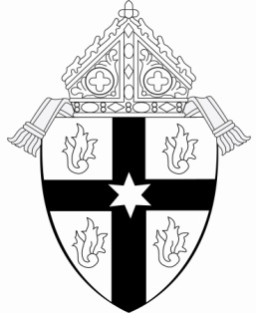
CATHOLIC DIOCESE OF SAGINAW
REPORT OF SUNDAY MASS ATTENDANCE
OCTOBER 2025

PARISH __________________________________ CITY ________________________________

SPECIFIC CHURCH _____________________________________ CITY ____________________

VICARIATE # _____ Pastor/Administrator ___________________________________________

MASSES  (Indicate Time) | Oct.  4-5 | Oct.  11-12 | Oct.  18-19 | Oct.  25-26 | TOTAL
Saturday ______ p.m.
Saturday ______ p.m.

Sunday _______ a.m.

Sunday _______ a.m.

Sunday _______ a.m.

Sunday _______ a.m.

Total Attendance _____________

Average Weekend
Attendance _____________
1/4 of total
_________________________________________
Signature of Pastor/Administrator

NOTE: Please count all people present at each weekend Mass in October, no matter what their age, and indicate if there were any special circumstances which may have caused an unusual increase or decrease in attendance that weekend.

Please return this form to the Office of Human Resources by Monday, November 10, 2025.

OCTOBER COUNT OF MASS ATTENDANCE

Procedures

- Appoint a team of “counters” to take the count at each Mass at each church on the weekend. The pastor may want to meet with the counters prior to the counting to discuss the logistics, as well as to stress the importance of consistency and accuracy during the counting process.

- For parishes that have merged, counters should take separate counts for each church with a weekend liturgy and fill out forms for each church, identifying both the New Parish name and the specific church.

For instance, parishes A, B, and C have merged into a New Parish (with a parish church, an additional church, and an occasional use church). The New Parish would submit three forms – one for the parish church, and the 2nd for the additional church. The church for occasional use may not have a weekend liturgy. If that is the case, please state on the 3rd form the name of the church and indicate “no Masses”.

- All people in attendance should be counted. This would include all adults, as well as children, regardless of age.

- Indicate on each form if there were any special circumstances which may have caused an unusual increase or decrease in attendance that weekend.

- Attendance is totaled and divided by four to determine the average attendance for October.

- Please keep a copy of your completed form for your parish records and send the original to the Office of Human Resources.

